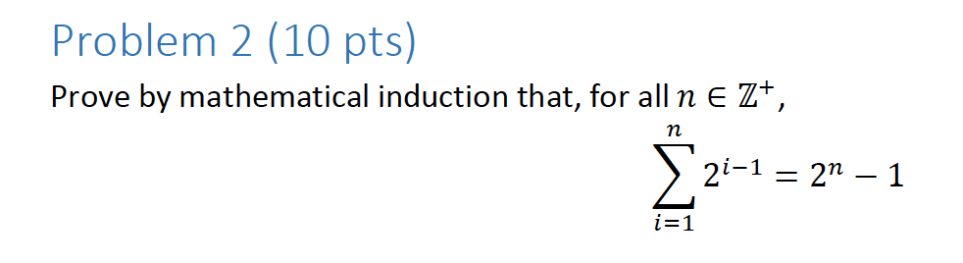

Base Case: k = 1

∑11 21-1 = 21-1

= 1 = 1

Thus, the Base Case Holds.

Now I will assume that ∑1k 2k-1 = 2k – 1 is true, since the Base Case holds.

Accordingly, I will plug in k+1.

Prove: ∑1k+1 2k-1 = 2k – 1

∑1k+1 2k+1-1 = ∑1k 2k-1 + 2k+1-1.

Now we can plug in our base case.

And since we know that the first part is true (the base case) and the second part is also true, since k can be any arbitrary number, we must have that ∑1n 2i-1 = 2n-1

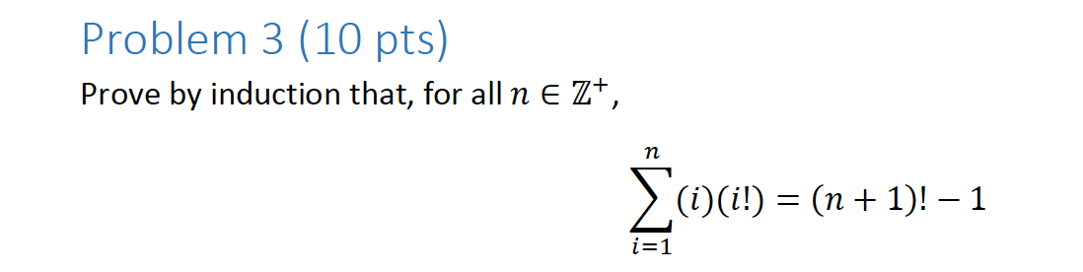

Base Case: n=1

∑i=11 (i)(i!) = (1+1)!-1

(1)(1!) = (2)! – 1

1 = 1

Thus, the base case holds.

Since the base case holds, I will assume that ∑i=1n (i)(i!) = (n+1)!-1 is true.

Now I will plug in n+1.

∑i=1n+1 (i)(i!) = ∑i=1n i(i!) + (n+1)((n+1)+1)!

Since we know that our base case holds, we only need to determine

if (n+1) ((n+1)+1)! = (n+1)!-1.

Since:

((n+1)+1)!(n+1) = (n+2)! (n+1) =

